Trainer Tracking and Management System
Introduction
The Trainer Tracking and Management System is a web-based application developed to simplify and automate the process of managing trainers, schedules, employee activities, and attendance records within an organization or training institute. The project is designed using modern web technologies including React for the frontend and Node.js with Express for the backend. The system provides an efficient digital solution that replaces manual tracking methods such as spreadsheets, paper registers, and unorganized communication systems.
In many organizations and educational institutions, trainer management is often handled manually, which can lead to problems such as data redundancy, scheduling conflicts, inaccurate attendance records, and inefficient communication between administrators and trainers. This project aims to solve these issues by providing a centralized platform where administrators can manage trainers, create schedules, monitor activities, and store records digitally.
The application follows a client-server architecture where the frontend handles the user interface and user interactions while the backend manages data processing, APIs, and business logic. The system is scalable, user-friendly, and capable of handling multiple trainers and sessions efficiently.

Objectives of the Project
The primary objectives of the Trainer Tracking and Management System are:
- To automate trainer and employee tracking processes.
- To maintain digital attendance and scheduling records.
- To reduce manual paperwork and data entry errors.
- To improve communication between trainers and administrators.
- To provide a centralized dashboard for management.
- To create a responsive and user-friendly web application.
- To demonstrate the practical implementation of React and Node.js technologies.

Technologies Used
The project uses modern web development technologies to ensure performance, scalability, and maintainability.
Frontend Technologies
- HTML5
- CSS3
- JavaScript (ES6)
- React.js
- React Hooks
- JSX
- Bootstrap (for styling)
Backend Technologies
- Node.js
- Express.js
Development Tools
- Visual Studio Code
- npm (Node Package Manager)
- Git and GitHub

System Architecture
The system follows a layered architecture:
1. Frontend Layer
The frontend is built using React.js. It provides interactive user interfaces and communicates with the backend using APIs. Components are used to maintain modularity and reusability.
2. Backend Layer
The backend is developed using Node.js and Express.js. It handles routing, API creation, data processing, and communication between frontend and server resources.
3. Data Management
The project manages trainer information, schedules, and attendance records dynamically. Data can be integrated with external services such as Google Sheets for real-time storage and tracking.

Features of the System
1. User Dashboard
The dashboard acts as the main control panel of the application. It displays trainer details, schedules, and attendance information in an organized manner.
Functions:
- View trainer information
- Monitor active sessions
- Display attendance records
- Show notifications and updates

2. Trainer Management
Administrators can add, update, and manage trainer records through the interface.
Functions:
- Add new trainer
- Update trainer details
- Delete trainer records
- Assign schedules

3. Attendance Tracking
The system records trainer attendance digitally.
Benefits:
- Reduces manual errors
- Real-time updates
- Easy report generation
- Improved accuracy

4. Schedule Management
The application allows administrators to create and manage training schedules efficiently.
Functions:
- Assign batches
- Set training timings
- Update schedules dynamically
- Prevent schedule conflicts

5. Responsive User Interface
The frontend is designed using responsive web design principles, ensuring compatibility across devices such as:
- Mobile phones
- Tablets
- Laptops
- Desktop computers

React Concepts Used in the Project
The project extensively uses React concepts taught during development.
1. Components
The application is divided into reusable components such as:
- Header
- Footer
- UserCard
- UserList
- Dashboard
This improves code reusability and maintainability.

2. JSX
JSX is used to create dynamic UI elements within JavaScript.
Example:
function Header() {
return <h1>Trainer Dashboard</h1>;
}

3. Props
Props are used to transfer data between components.
Example:
<UserCard name="Madhav" role="Trainer" />
Props help maintain one-way data flow.

4. State Management
The useState hook is used to handle dynamic data such as:
- Attendance status
- Trainer information
- Form inputs
Example:
const [count, setCount] = useState(0);

5. Event Handling
React event handling is used for:
- Button clicks
- Form submission
- Input changes
Example:
<button onClick={handleClick}>Submit</button>

Backend Functionality
The backend manages:
- API requests
- Trainer records
- Schedule data
- Attendance updates
Express.js is used to create routes and handle server operations efficiently.
Example API Route:
app.get('/trainers', (req, res) => {
res.send(trainers);
});

Working of the System
The system works through the following process:
- User opens the application.
- React frontend loads the dashboard.
- User interacts with components.
- Frontend sends API requests to backend.
- Backend processes requests.
- Updated data is returned and displayed dynamically.
This architecture ensures smooth communication between frontend and backend.

Advantages of the Project
1. Automation
The system reduces manual work and automates attendance and scheduling.
2. Accuracy
Digital records minimize human errors.
3. Scalability
The application can be expanded with additional features.
4. User-Friendly Interface
Simple and responsive UI improves user experience.
5. Real-Time Management
Administrators can monitor activities instantly.

Challenges Faced During Development
Several challenges were encountered during development:
1. State Management
Managing dynamic data and ensuring proper re-rendering in React required careful handling.
2. Component Communication
Passing data between multiple nested components using props required structured planning.
3. API Integration
Connecting frontend and backend and handling asynchronous requests was challenging initially.
4. Responsive Design
Making the application responsive across all devices required media queries and layout optimization.

Future Enhancements
The project can be further improved with the following features:
- Authentication and authorization system
- Database integration using MongoDB
- Email notification system
- Real-time chat functionality
- Admin and employee role separation
- Report generation in PDF or Excel format
- Cloud deployment

Learning Outcomes
Through this project, the following concepts and skills were learned:
- Frontend development using React
- Component-based architecture
- State and props management
- Backend development with Node.js and Express
- API integration
- Responsive web design
- Real-world project structuring
- Debugging and problem-solving

Future Enhancements
The Trainer Tracking and Management System has strong potential for future expansion through the integration of Artificial Intelligence, Machine Learning, and advanced analytics features. These improvements will make the system more intelligent, automated, and data-driven.
1. AI-Based Assistant Bot
In future versions, an AI-powered chatbot will be integrated into the system to assist trainers and administrators. The chatbot will act as a virtual assistant capable of handling trainer-related queries in real time.
Features of the AI Bot:
- Provide trainer batch information instantly
- Display upcoming schedules and sessions
- Answer attendance-related queries
- Notify trainers about class timings and updates
- Provide automated reminders
- Handle common administrative questions
Example Use Cases:
- “Which batch do I have today?”
- “Show my attendance for this week.”
- “What is my next session timing?”
- “How many students are assigned to my batch?”
The chatbot can be developed using Natural Language Processing (NLP) techniques and integrated with machine learning APIs for intelligent responses.

2. Machine Learning-Based Analytics
Machine Learning models can be added to analyze trainer and batch data to improve operational efficiency and decision-making.
Planned ML Features:
- Trainer performance prediction
- Attendance trend analysis
- Batch performance evaluation
- Prediction of low attendance patterns
- Automated scheduling recommendations
- Trainer workload analysis
These ML operations will help management identify:
- High-performing trainers
- Irregular attendance trends
- Optimal training schedules
- Resource allocation improvements

3. Data Visualization Dashboard
Future versions of the project will include advanced data visualization modules to present trainer and attendance data in graphical form.
Visualization Features:
- Attendance charts
- Trainer performance graphs
- Monthly batch reports
- Interactive dashboards
- Real-time analytics
- Student engagement statistics
Technologies Planned:
- Chart.js
- Recharts
- D3.js
- Power BI or Looker Studio integration
Example Visual Reports:
- Pie charts for attendance distribution
- Bar graphs for trainer performance
- Line charts for monthly attendance growth
- Heatmaps for batch activity analysis
These visualizations will help administrators quickly understand system data and make informed decisions.

4. Smart Notification System
AI-based notification systems can be implemented to send:
- Schedule reminders
- Attendance alerts
- Batch update notifications
- Performance warnings
- Automated announcements
Notifications can be delivered through:
- Email
- SMS
- WhatsApp integration
- In-app alerts

5. Predictive Scheduling System
A predictive scheduling module can analyze:
- Trainer availability
- Historical attendance
- Batch timings
- Workload patterns
Using machine learning algorithms, the system will automatically recommend optimized schedules to reduce conflicts and improve productivity.

6. Voice Assistant Integration
Future updates may also include voice-based interaction where trainers can ask questions using voice commands.
Example:
- “Show my next class”
- “Check today’s attendance”
- “Open trainer dashboard”
This feature can improve accessibility and user experience.

7. Cloud Deployment and Scalability
The system can be deployed on cloud platforms such as:
- AWS
- Google Cloud
- Microsoft Azure
Cloud deployment will provide:
- Better scalability
- Data security
- Remote accessibility
- Backup and recovery support

8. Advanced Reporting System
Future versions can generate automated:
- PDF reports
- Excel sheets
- Attendance summaries
- Trainer performance reports
This will simplify administrative documentation and reporting tasks.

Summary of Future Scope
The future scope of the Trainer Tracking and Management System focuses on transforming the application into an intelligent, AI-driven management platform. By integrating machine learning, chatbot support, predictive analytics, and data visualization tools, the system will not only manage trainer operations but also provide actionable insights and automation capabilities.
These enhancements will improve productivity, reduce administrative workload, and create a smarter training management ecosystem suitable for modern educational institutions and organizations.

Snippets

1 Trainer Page
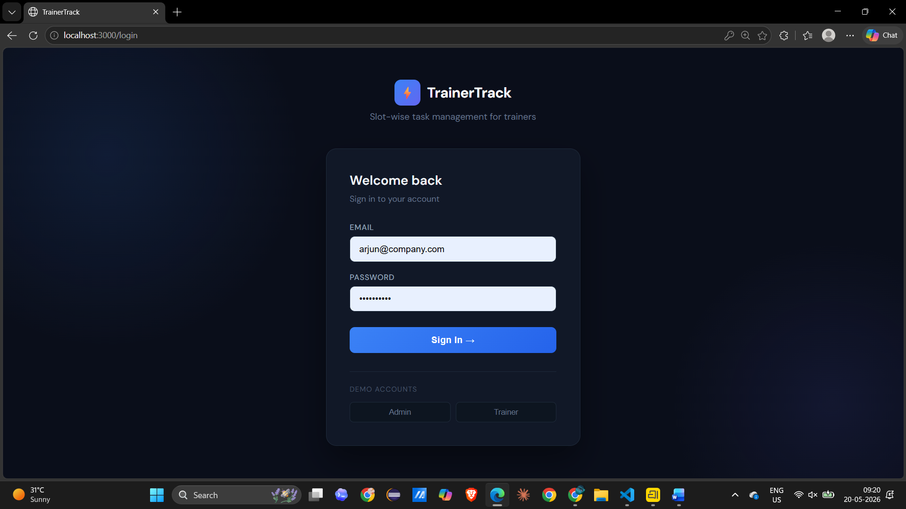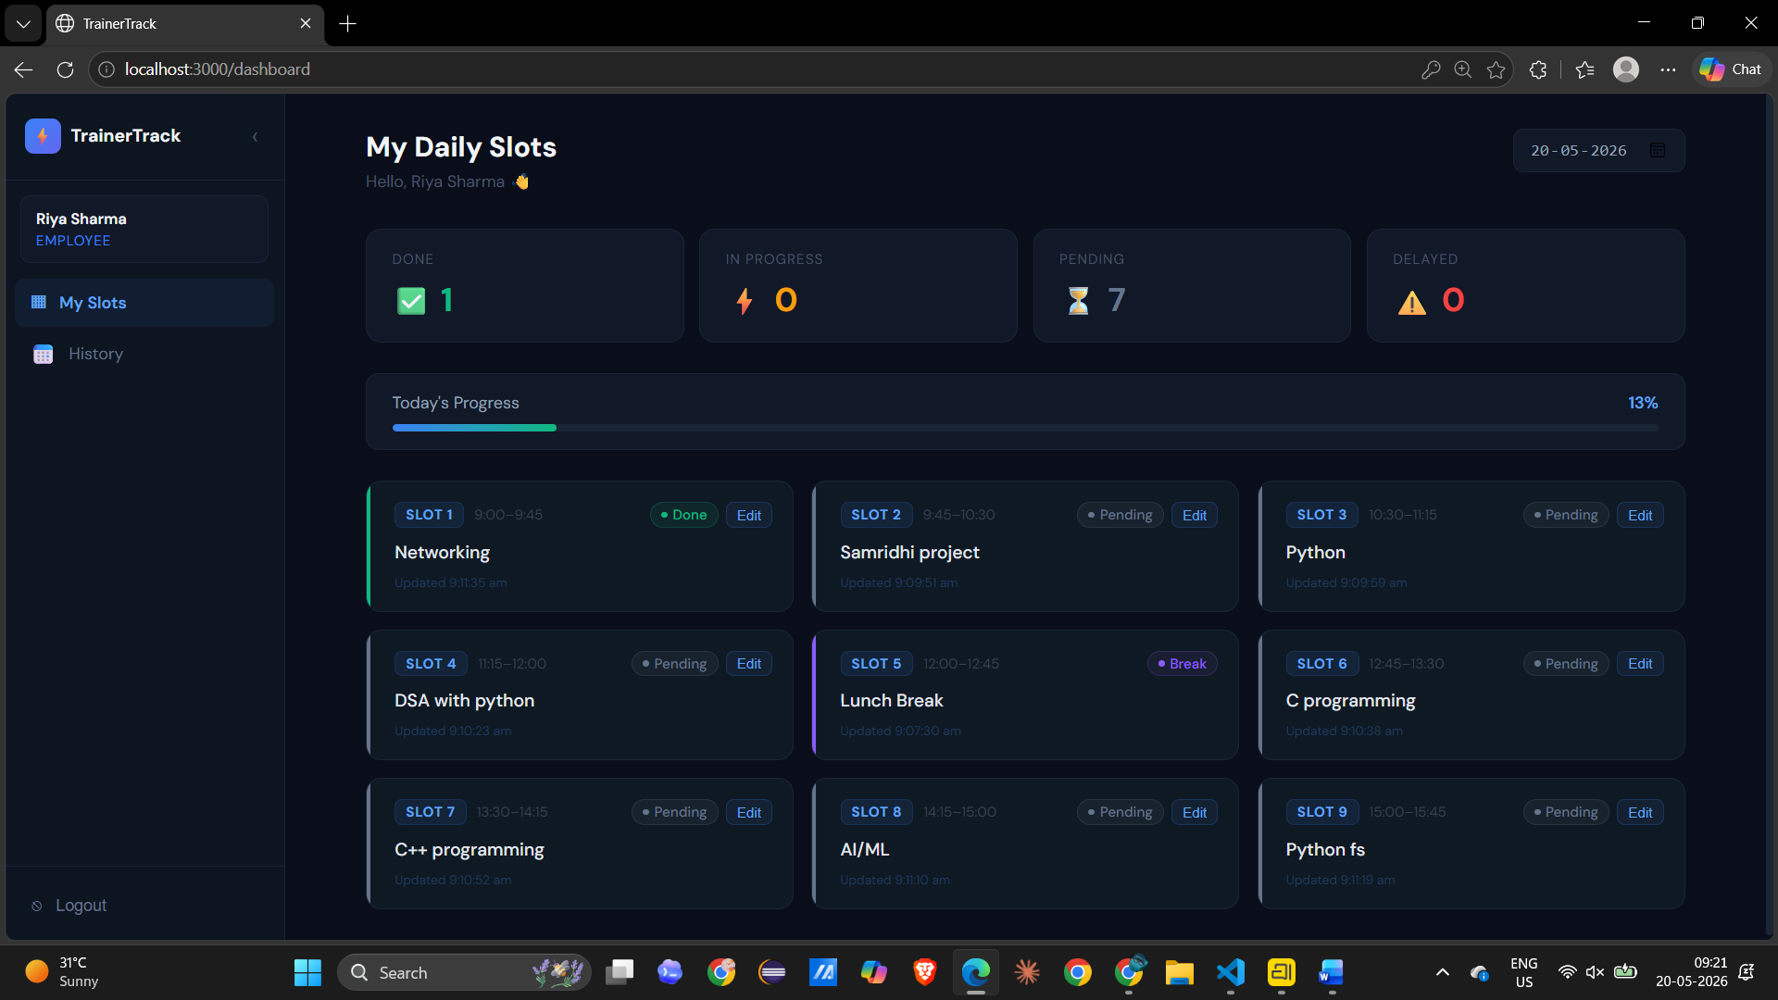

2 Admin Login
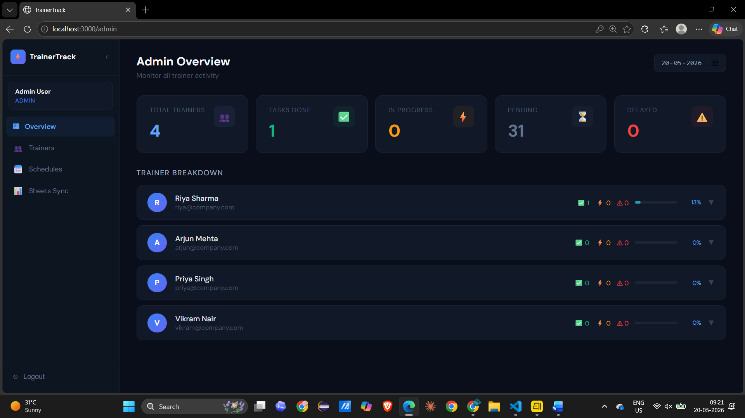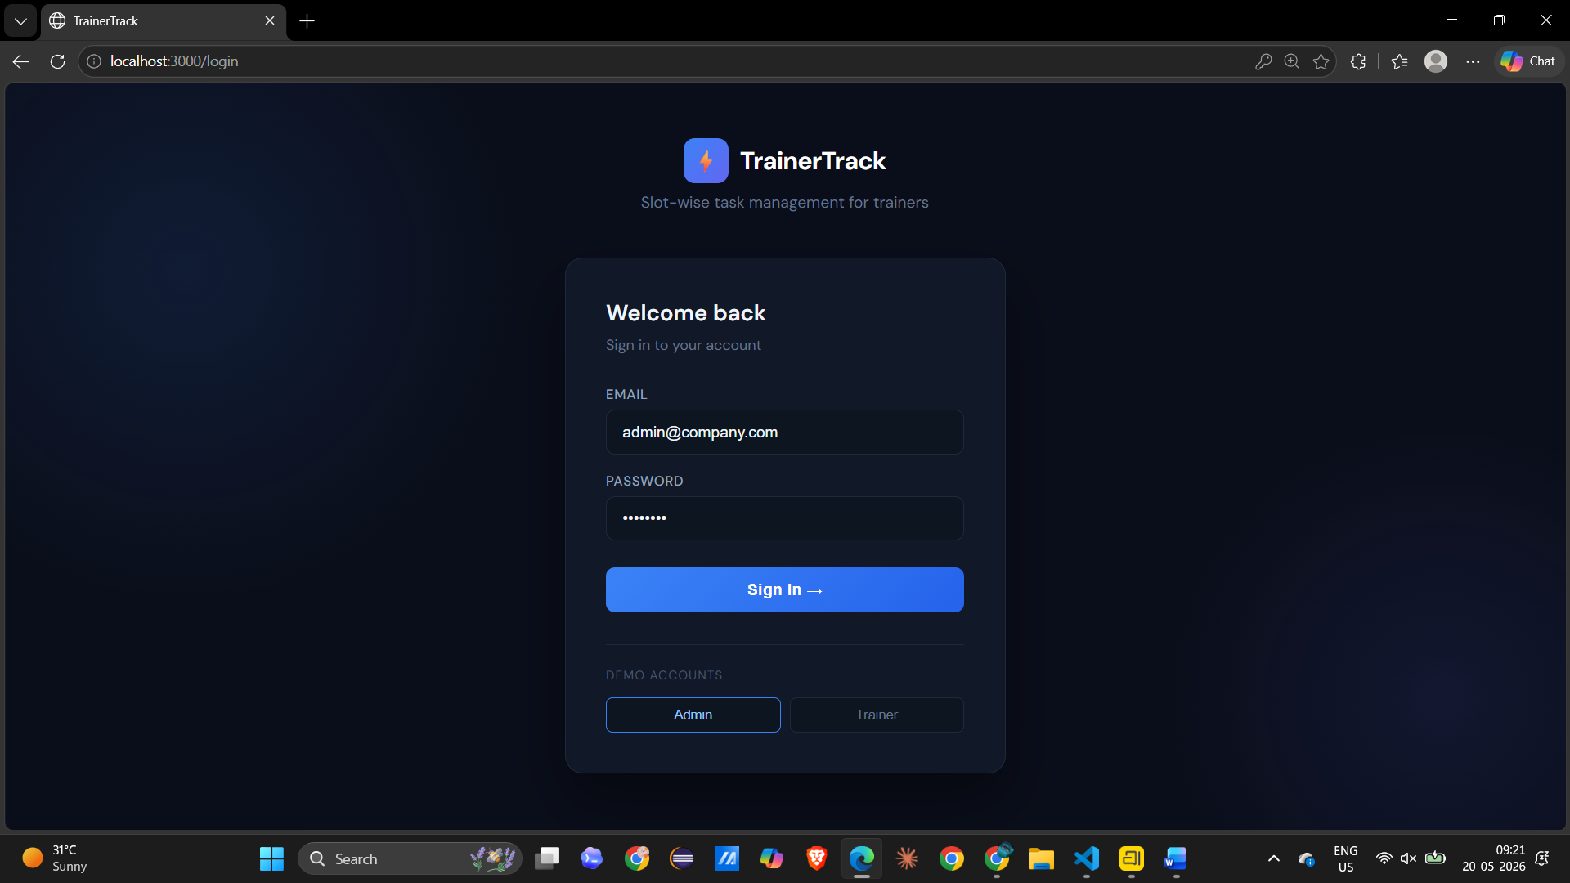
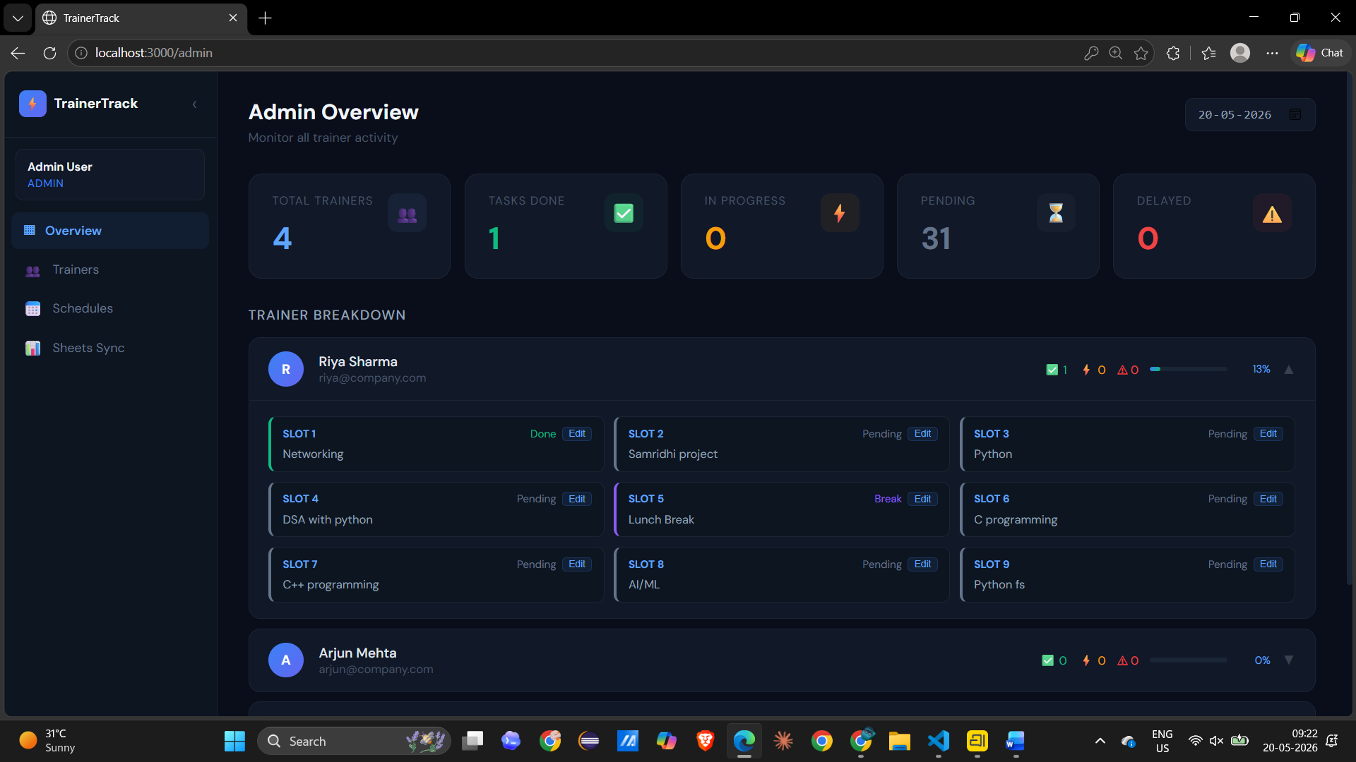

3 Database
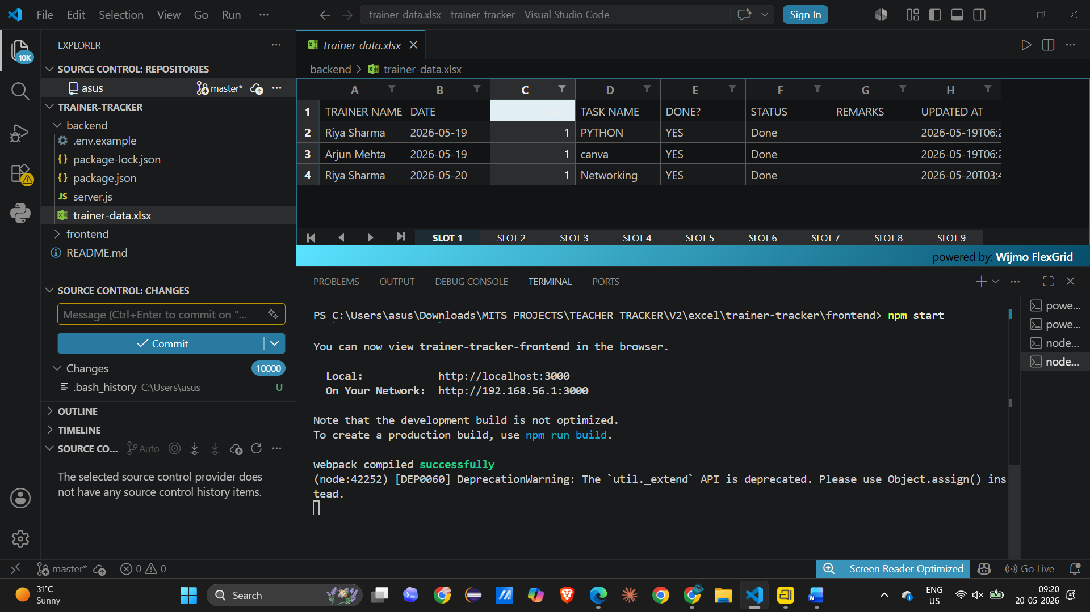

Conclusion
The Trainer Tracking and Management System successfully demonstrates the practical implementation of a modern full-stack web application. The project simplifies trainer management, attendance tracking, and scheduling processes through automation and responsive design. By using React for frontend development and Node.js with Express for backend functionality, the system provides a scalable and efficient solution suitable for educational institutions and organizations.
The project also serves as an excellent learning platform for understanding React concepts such as components, props, state management, and event handling in a real-world environment. With future enhancements such as authentication, database integration, and cloud deployment, the system can evolve into a fully production-ready enterprise application.

